**MAWLANA BHASHANI SCIENCE AND TECHNOLOGY UNIVERSITY**

SANTOSH, TANGAIL-1902



DEPARTMENT OF INFORMATION AND COMMUNICATION TECHNOLOGY

**Course Title: Computer Based Numerical Method Lab**

**Course Code: ICT-2102**

**Lab Report on: Taylor Series Approximation for sin(x), cos(x), and 1/(1-x) in MATLAB**

**Lab Report No: 03**

|  |  |
| --- | --- |
| Submitted By | Submitted To |
| Name: Kuldip Saha Mugdha  ID: IT22018  2nd Year, 1st Semester  Session: 2021-2022  Dept. of ICT, MBSTU | Dr. Mst. Nargis Akter  Professor  DEPARTMENT OF INFORMATION AND COMMUNICATION TECHNOLOGY  MAWLANA BHASHANI SCIENCE AND TECHNOLOGY UNIVERSITY |

**Date of Performance:**

**Date of Submission:**

**Experiment No : 02**

**Experiment Name :** Taylor Series Approximation for sin(x), cos(x), and 1/(1-x) in MATLAB

**Objective:**

The objective of this experiment is to approximate functions such as sin(x), cos(x), and 1/(1-x) using the Taylor series expansion in MATLAB and visualize the results using plots.

**Materials:**

* MATLAB software installed on a computer

**Code, Procedure, and Output:**

**1. Taylor Series Approximation of sin(x) (Up to 5th order)**

The Taylor series for sin(x) around x = 0 is given by:

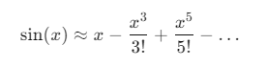

MATLAB code to approximate and plot sin(x) using Taylor series expansion up to 5th order:

**Code:**

% Define the symbolic variable

syms x;

% Taylor series expansion for sin(x)

f = sin(x);

a = taylor(f, 'order', 5);

% Plot the Taylor series approximation

fplot(a, [-2*pi, 2*pi]); % Plot from -2π to 2π

title('Taylor Series Approximation of sin(x) (Order 5)');

xlabel('x');

ylabel('sin(x)');

grid on;

**Output:**

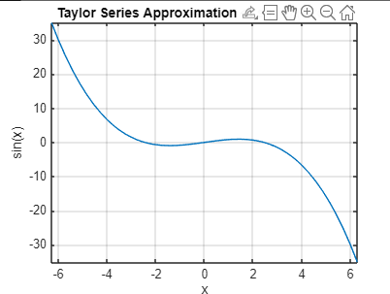

**Taylor Series Approximation of cos(x) (Up to 8th order)**

The Taylor series for cos(x) around x = 0 is given by:

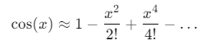

MATLAB code to approximate and plot cos(x) using Taylor series expansion up to 8th order:

**Code:**

% Define the symbolic variable

syms x;

% Taylor series expansion for cos(x)

g = cos(x);

b = taylor(g, 'order', 8);

% Plot the Taylor series approximation

fplot(b, [-2*pi, 2*pi]); % Plot from -2π to 2π

title('Taylor Series Approximation of cos(x) (Order 8)');

xlabel('x');

ylabel('cos(x)');

grid on;

**Output:**

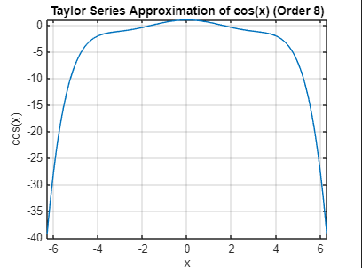

**Taylor Series Approximation of 1/(1 - x) (Up to 10th order)**

The Taylor series for 1/(1 - x) around x = 0 is given by:

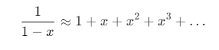

MATLAB code to approximate and plot 1/(1 - x) using Taylor series expansion up to 10th order:

**Code:**

% Define the symbolic variable

syms x;

% Taylor series expansion for 1/(1 - x)

h = 1/(1 - x);

c = taylor(h, 'order', 10);

% Plot the Taylor series approximation

fplot(c, [-2, 2]); % Plot from -2 to 2

title('Taylor Series Approximation of 1/(1 - x) (Order 10)');

xlabel('x');

ylabel('1/(1 - x)');

grid on;

**Output:**

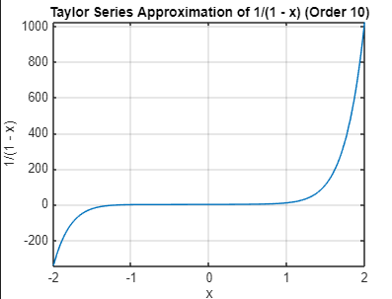

#### Discussion:

* **Taylor Series for sin(x):** The Taylor series for sin(x) up to the 5th order provides a good approximation around x = 0. However, since the approximation is truncated, it becomes less accurate as we move further away from 0, especially for large values of x.
* **Taylor Series for cos(x):** The Taylor series for cos(x) up to the 8th order results in a more accurate approximation compared to sin(x). The behavior of the approximation is very close to the actual function over a wider range of x, but it still shows slight deviations at the extremities.
* **Taylor Series for 1/(1 - x):** The Taylor series for the rational function 1/(1 - x) converges well near x = 0 but diverges as x approaches 1, where the original function has a singularity. This shows the limitation of Taylor series when approximating functions with singularities or discontinuities.
* **Error and Approximation:** In all cases, the Taylor series provides an excellent approximation near x = 0, but the accuracy decreases as we move away from this point. Increasing the order of the series improves the accuracy and the range of the approximation, but at a computational cost.